**Swift-T C128DCR Installation Instructions.**

The Swift-T Internal Swiftlink Compatible modem installs into the U1 socket of the C128DCR.

This is located near the cartridge slot. There needs to be a socket installed at this location.

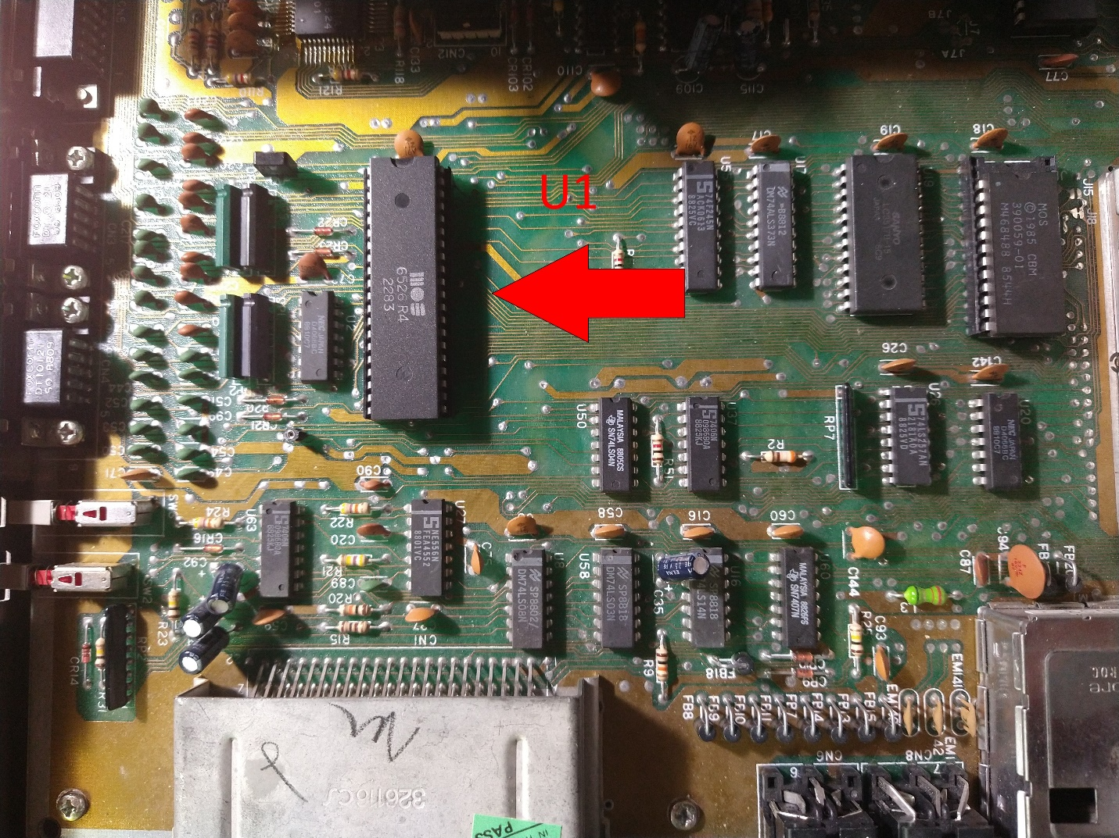

The next prerequisite is that the disk drive connection is vertical, most are but some have been seen with a 90-degree connector that interferes with the modem.

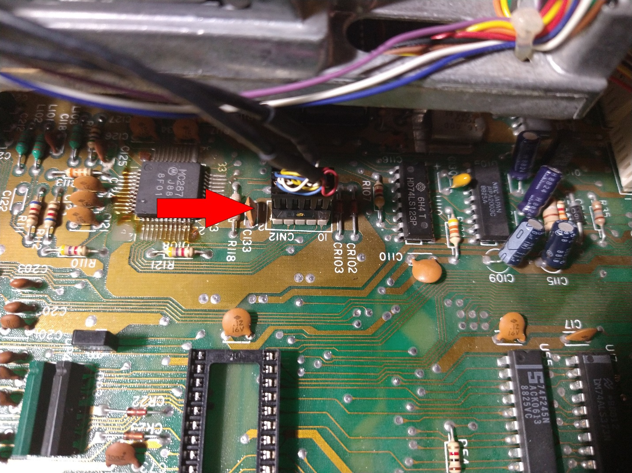

If your computer has a socket installed at U1 and the vertical drive connector like the above picture we are ready to install.

First remove the CIA (6526) chip located at U1.

Then install the modem with the larger portion towards the disk drive.

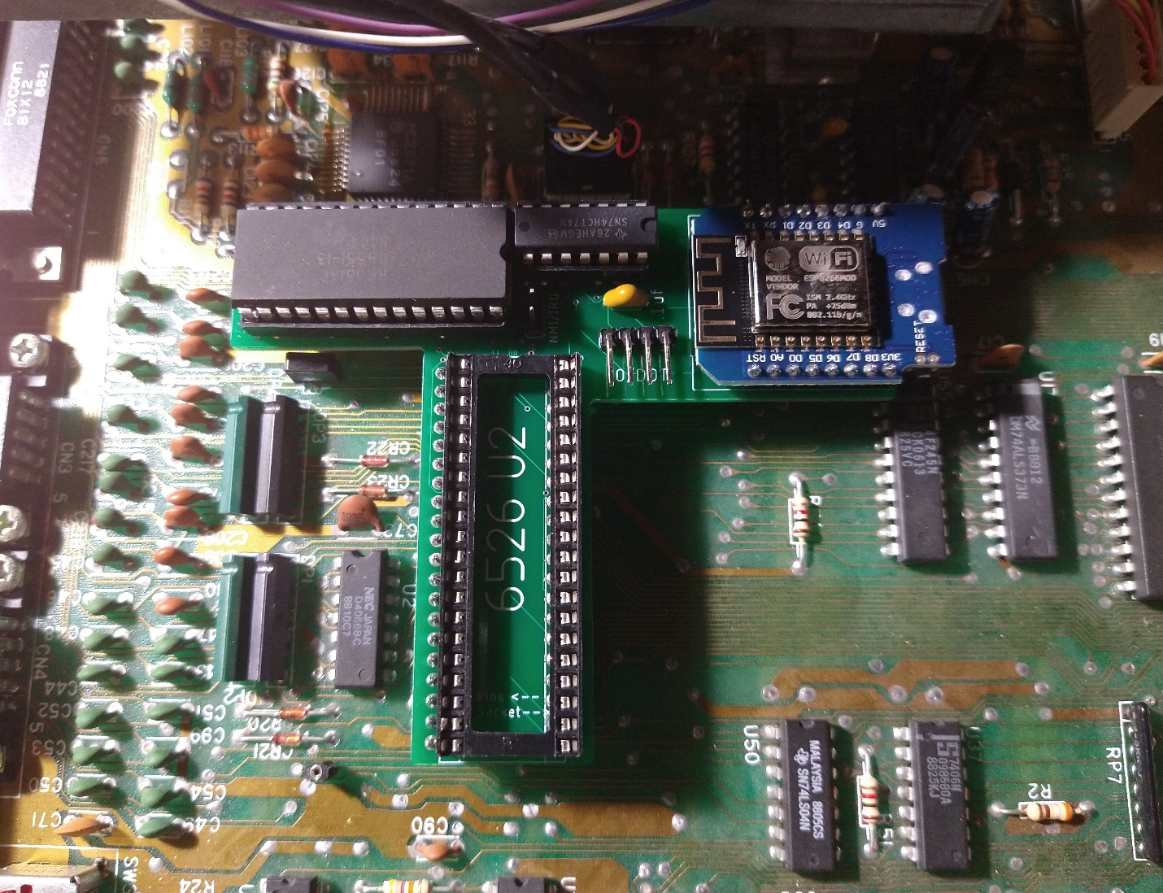

Then reinstall the cia into the socket on the modem. Pin 1 goes towards the disk drive.

(Top left of the socket in the above picture)

There 4 cables are included with the modem. Only 3 are used for the installation.

There are 3 short cables, and one long cable.

Any of the short cables can be used for the first 2 connections.

First is the NMI signal. The clip goes to pin 12 of U63. Make sure that the clip is firmly on the pin and not touching any other adjacent pins.

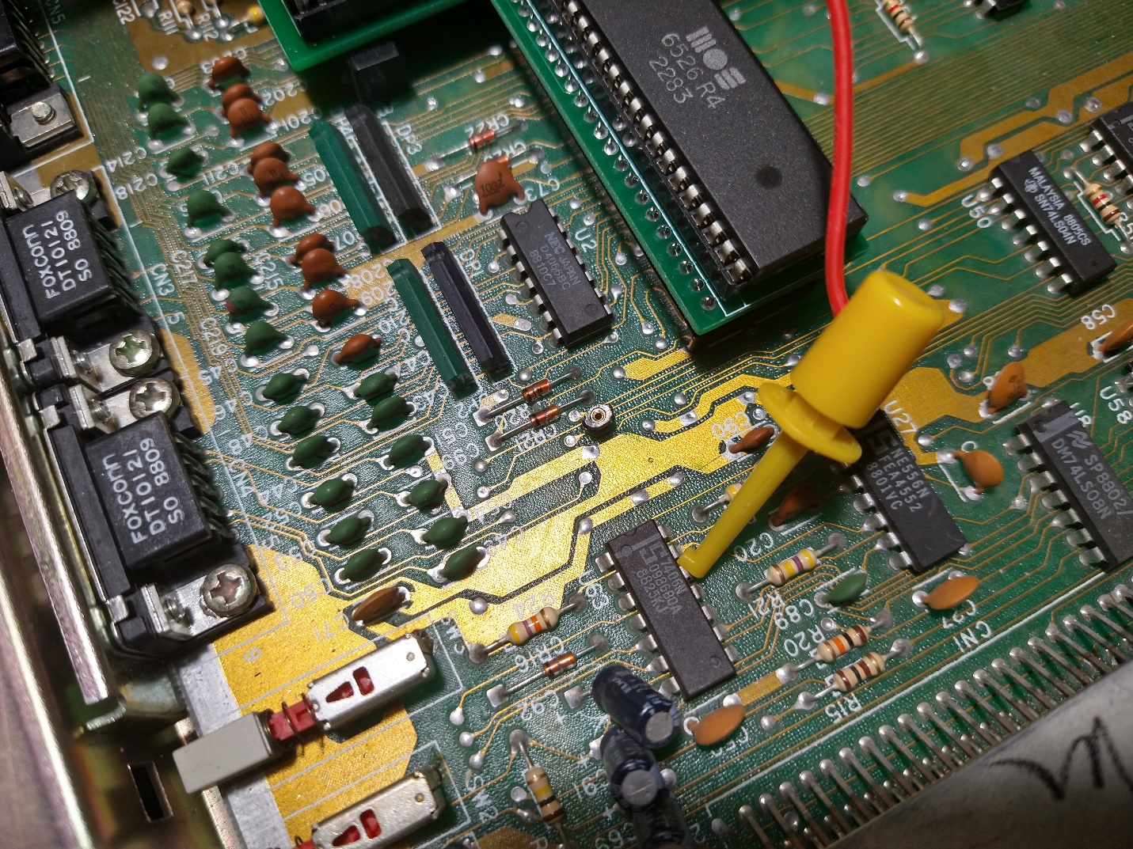

The other end of the NMI cable goes to the modem header labeled NMI/IRQ, and is installed on the IRQ side.

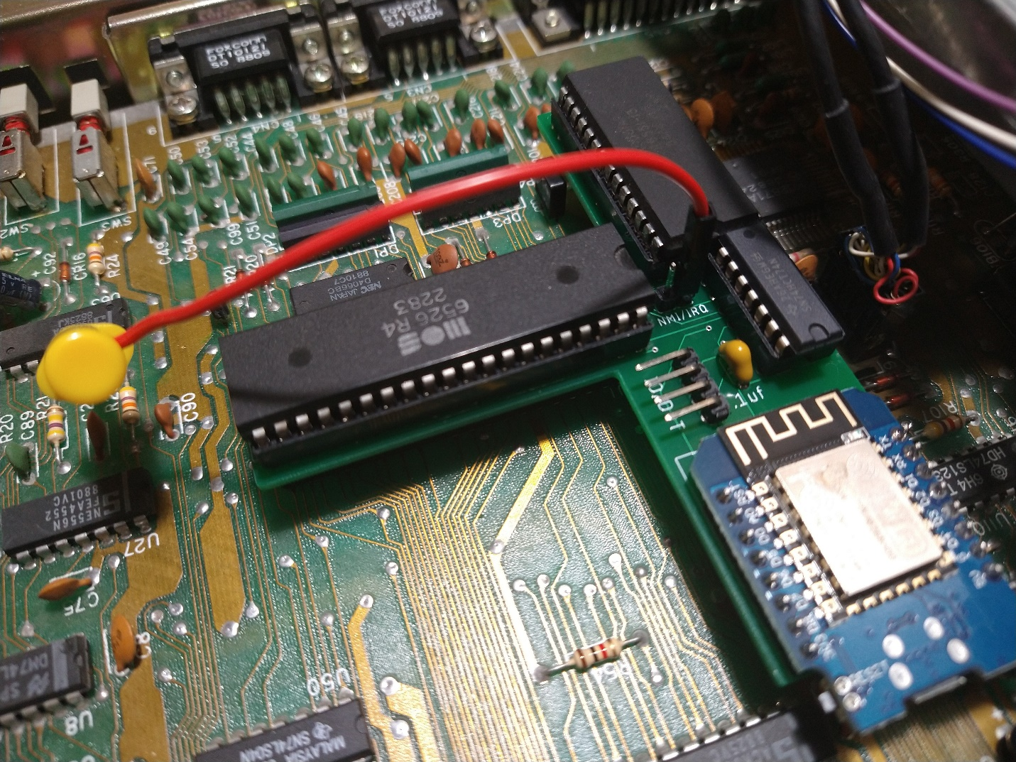

The Dot Clock is next. Use the clip to attach to FB18. This is a ferrite bead and has a long exposed lead.

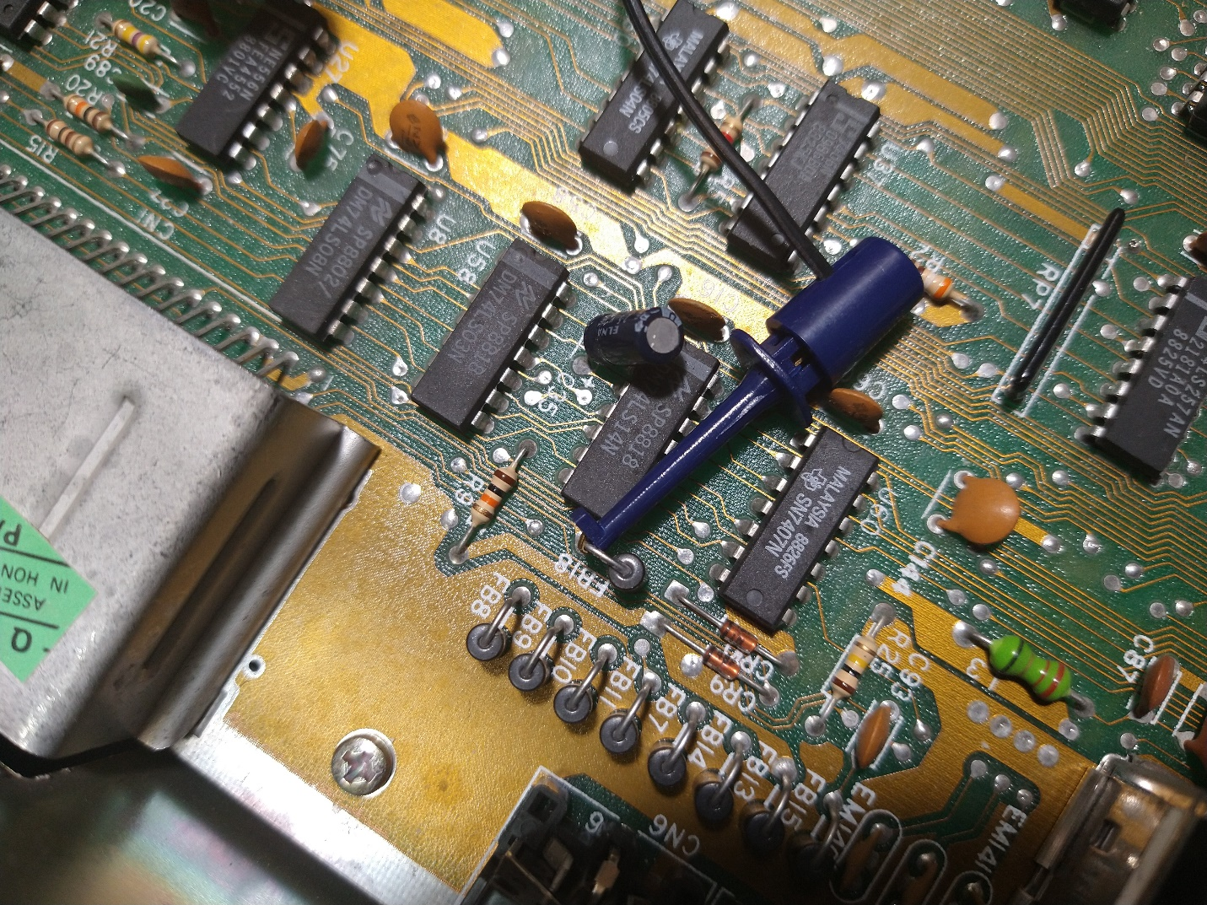

The other end goes to the IO/DOT header, 3rd pin from the left.

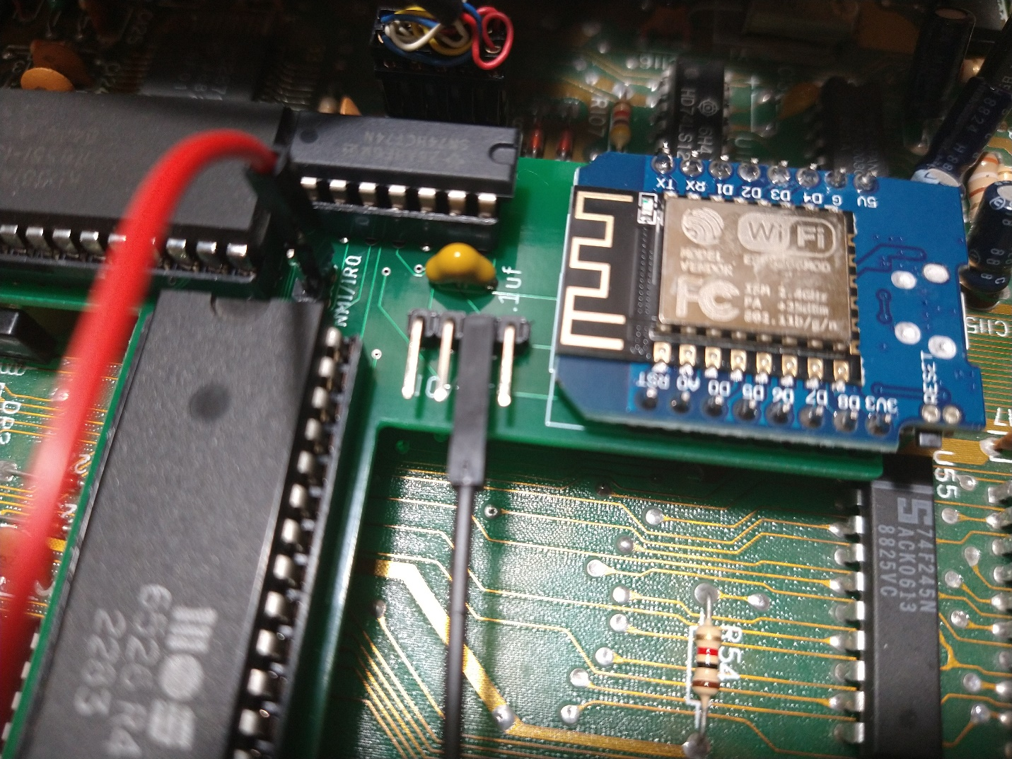

The last cable is for the IO address that the modem responds to.

You have 3 options, and they have their upsides and downsides.

The original Swiftlink modem supported DE00 or DF00 using the cartridge port. This works with all Swiftlink software, but occupies part of the cartridge address space.

This means that if you are trying to use other cartridges that use IO, you will have a conflict and they will not work.

Examples are.

Easyflash / Easyflash3 – Uses all the DE00-DF00 address space.

1700/1764/1750 REU uses DF00 - DF0F.

I imagine that the Kungfu Flash, Ultimate 1541 II+ and other style cartridges have similar requirements.

Most newer terminal / bbs software that supported Swiftlink also support the D700 IO address.

This left the cartridge port free and open for power users.

Examples of software that supports D700 addressing.

CCGMS – CCGMS Future

Desterm 3

Novaterm 9.6c

Dialogue 128

This is my recommended config for the internal modem.

It is also possible to share the D700 address with a Megabit 128 internal rom with no problems.

D700 is available at pin 12 of U3. This chip is located near the front of the machine, obscured by the power supply, slightly about the U36 open socket.

Use the provided long cable to attach to the pin, making sure it’s correctly seated, and not shorting any adjacent pins.

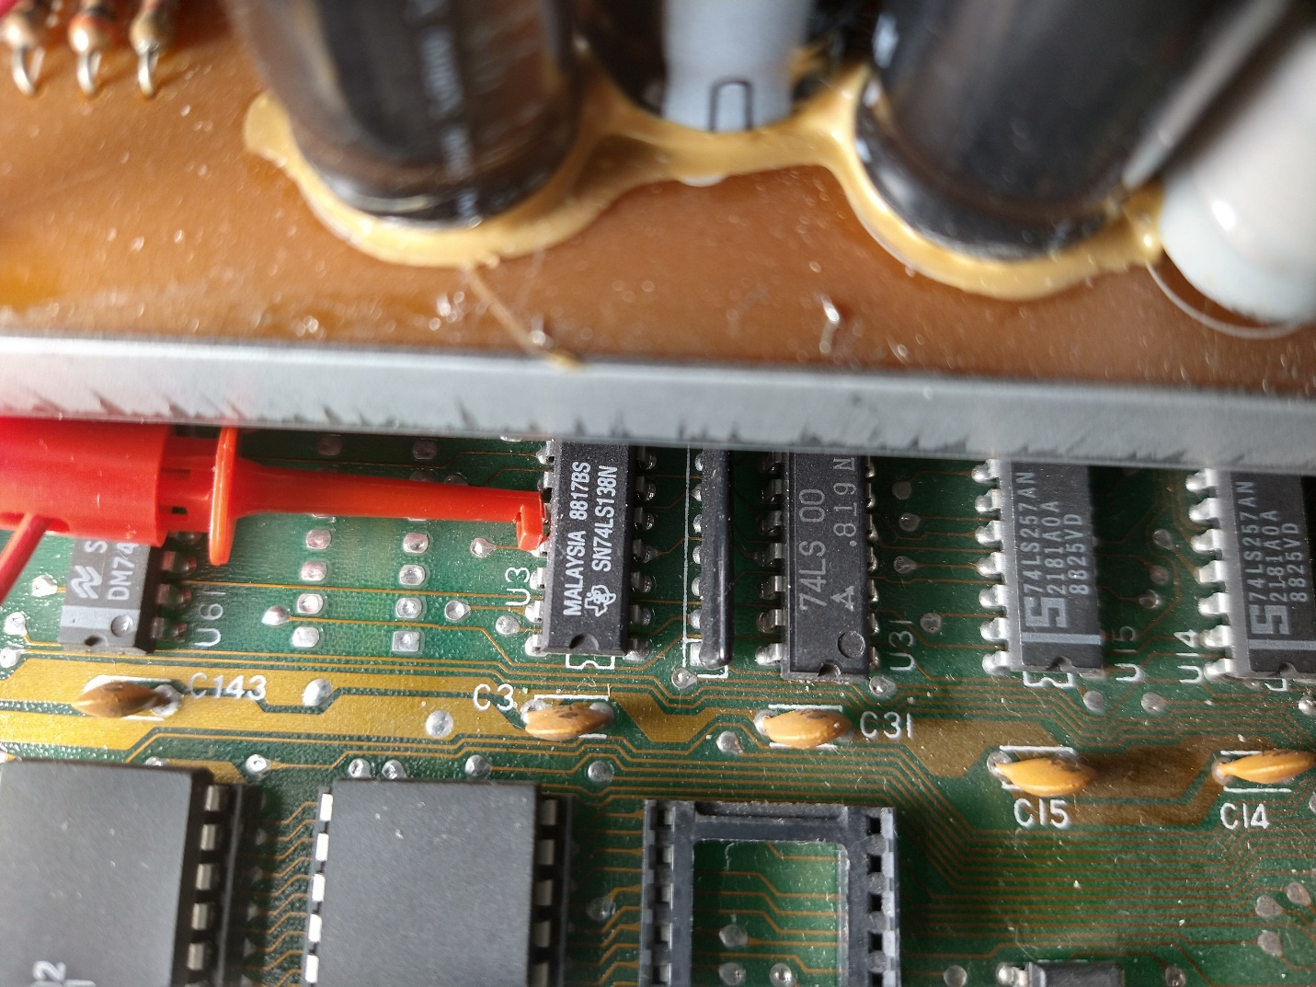

The end of this cable attaches to pin one of the IO/DOT connector.

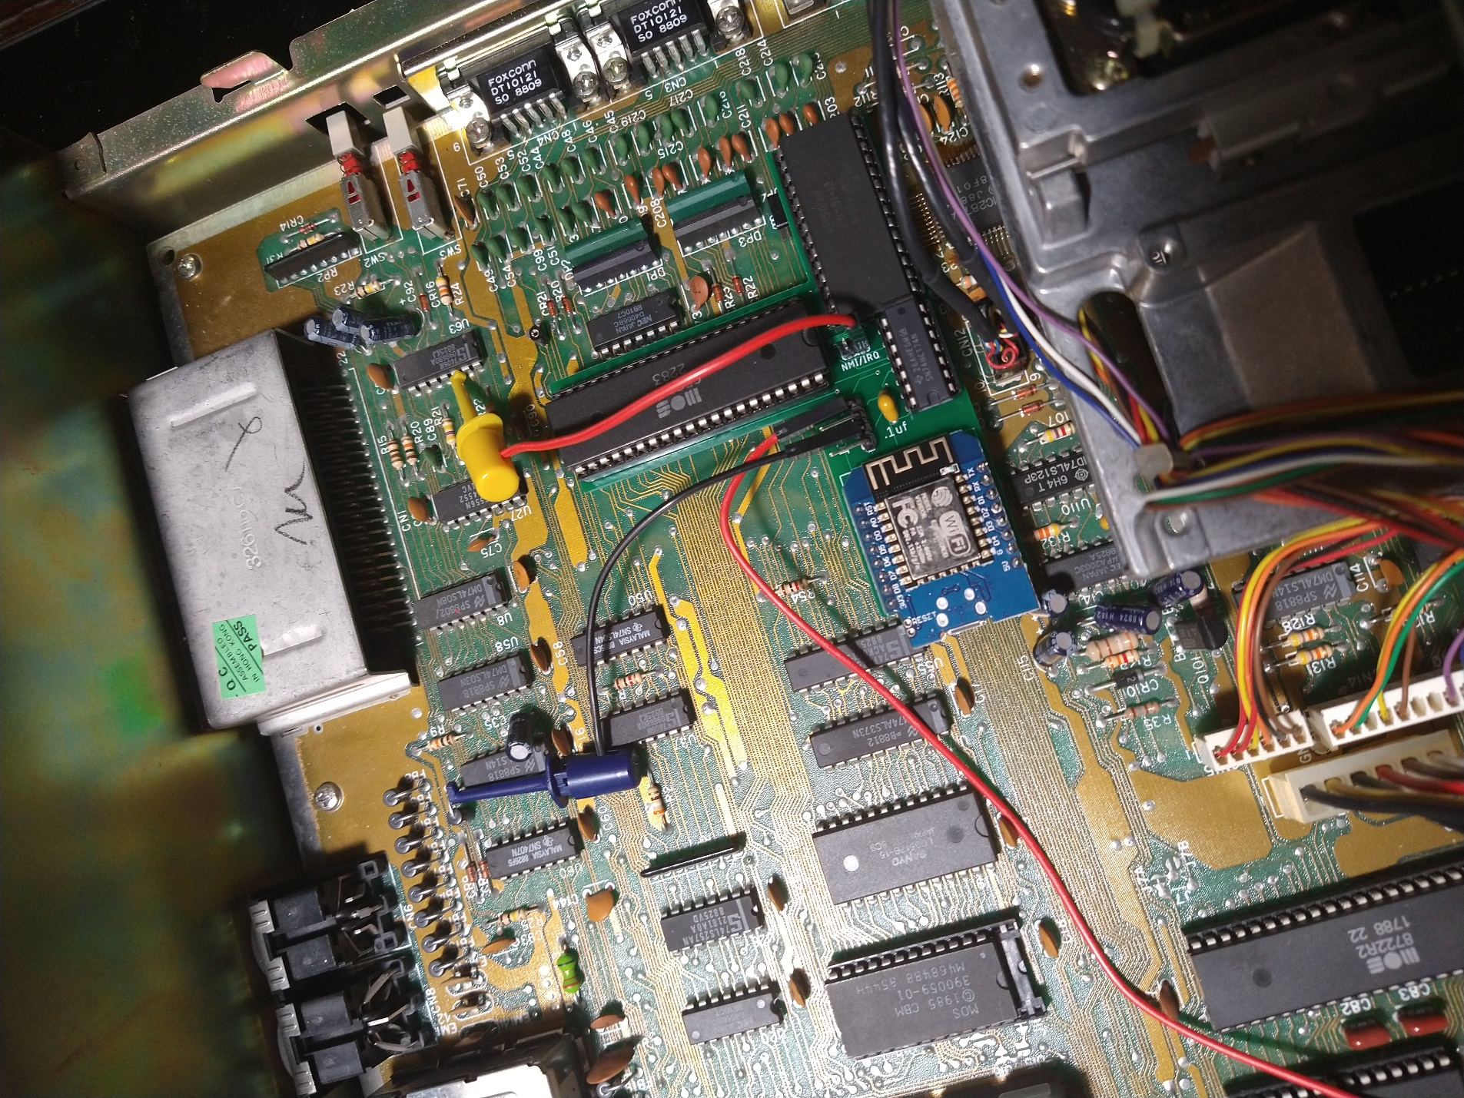

For DE00 you would use the short cable to the cartridge slot pin 7.

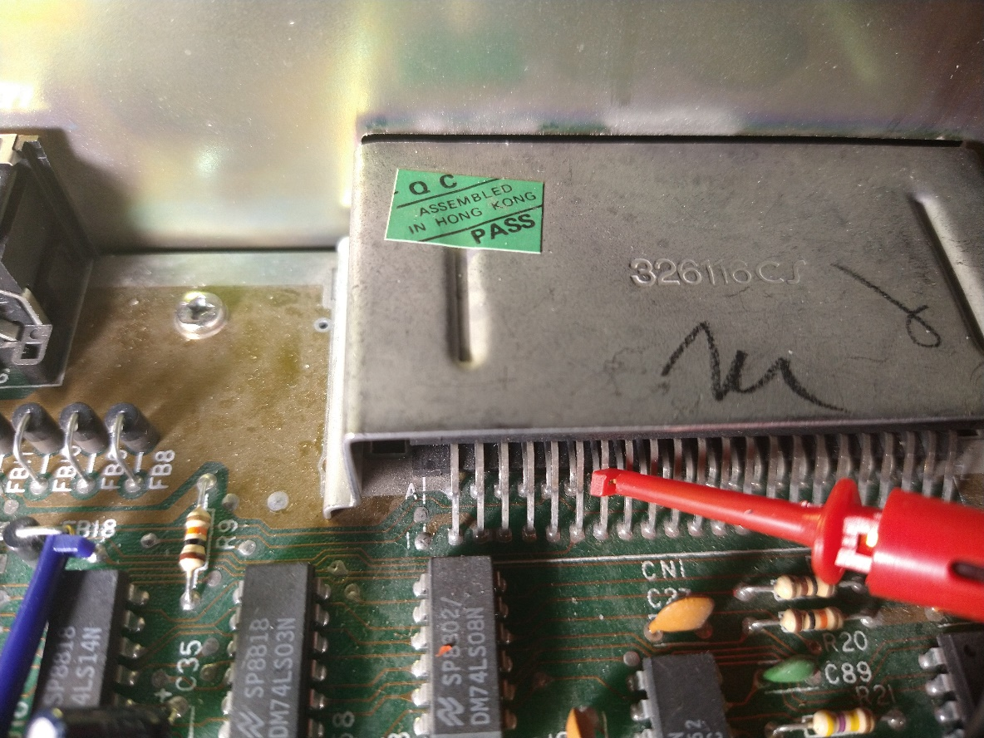

For D700 you would use the short cable to the cartridge slot pin 10.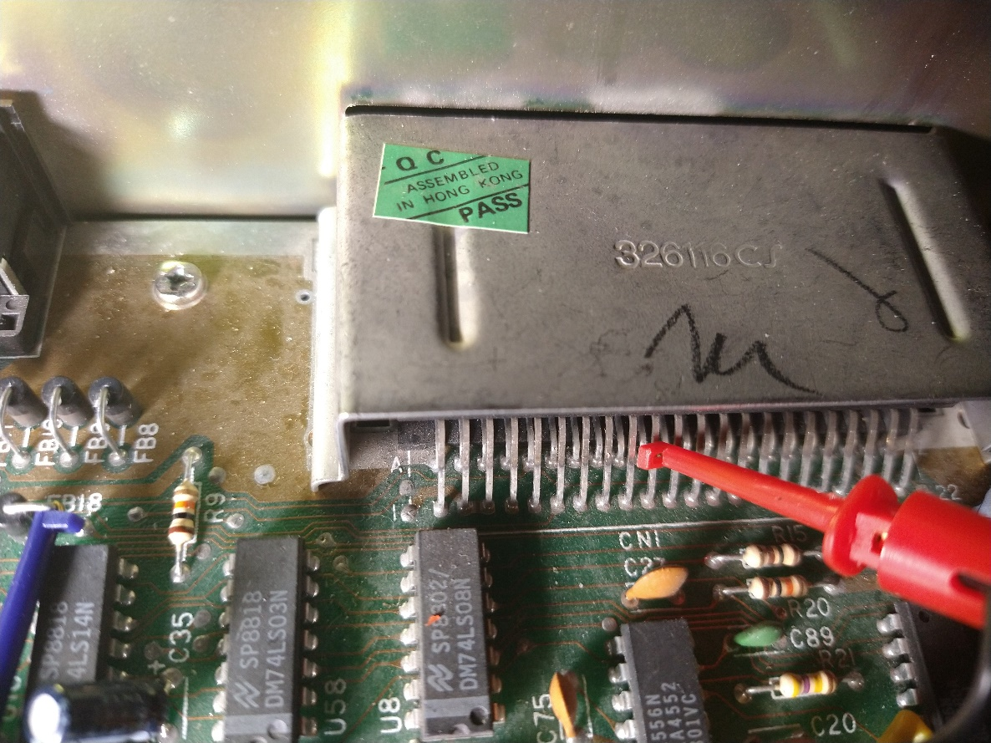

With the end of the cable attaching to pin one of the IO/DOT connector on the modem.